

Europass  Curriculum Vitae |  | 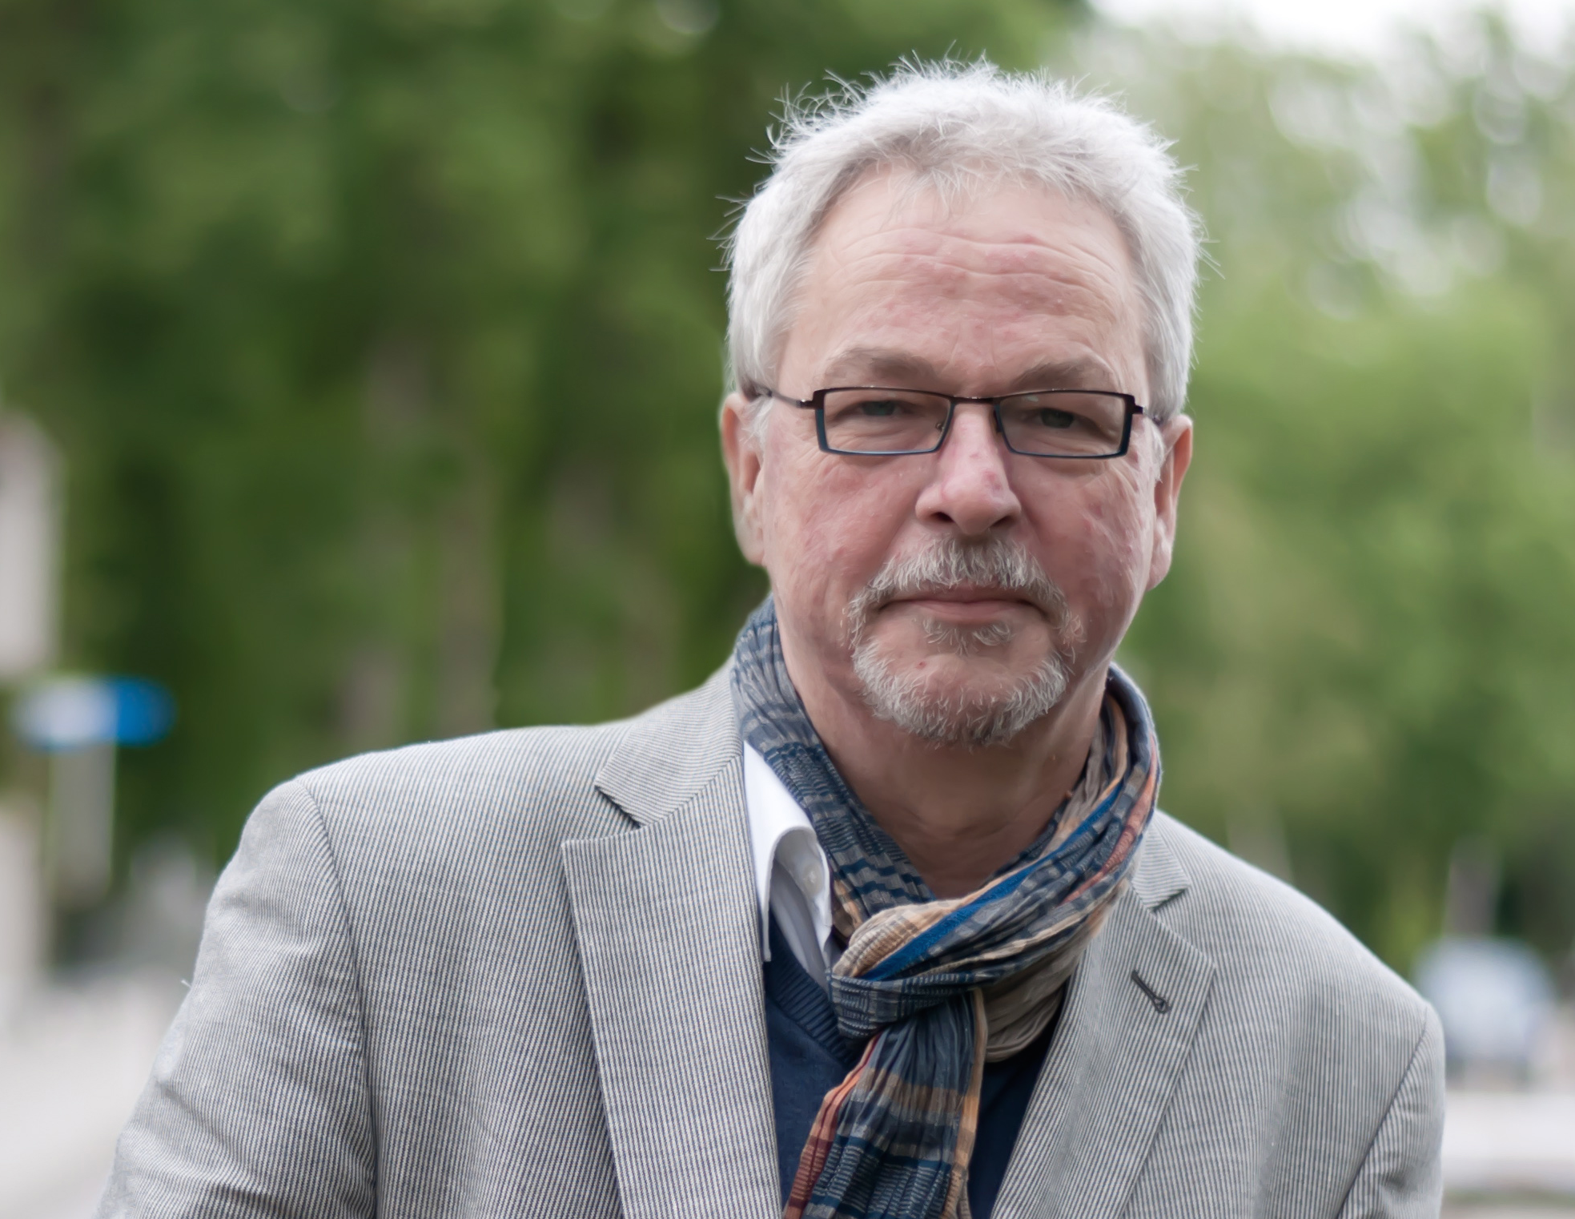
Personal information
Surname(s) / First name(s) |  | Ben Kokkeler
Address(es) |  | 266, Lonnekerspoorlaan, 7523ND, Enschede, The Netherlands
Telephone(s) |  | Mobile: +31 6 107 233 97
Fax(es)
E-mail |  | ben@kic-m.nl
Nationality |  | Dutch
Date of birth |  | 9th May 1958
Gender |  | Male
Desired employment / Occupational field |  | International co-operative research  International policy studies, consultancy and project management
Work experience |  | Policy advisor, change manager and researcher at several Dutch, German and European universities, research institutes and public institutions
Dates |  | 2014- senior researcher Saxion University of Applied Sciences, senior research fellow University of Twente, senior advisor innovation & change management public domain  2006-2014 senior advisor and expert group leader, BMC Group, Amersfoort, The Netherlands  2003-2006 Manager strategy and operations, Telematics Institute, Enschede, The Netherlands  2000-2003 Policy advisor and projectmanager, Rektorat Universitaet Dortmund, Dortmund, Germany  1988-2000 different positions at the University of Twente, Enschede, The Netherlands; director International Affairs, director International Graduate School, General Secretary of the European Consortium of Innovative Universities (www.eciu.org)  1979-1988 Board member and later on manager International Technical Enquiry Service of the TOOL Foundation, Amsterdam, The Netherlands
Occupation or position held |  | Policy advisor, projectmanager, manager, supervisor, senior researcher
Main activities and responsibilities |  | senior researcher, policy research, change management, management of knowledge intensive organisations
Name and address of employer |  | Saxion University of Applied Science, Research Centre for Urban & Environmental Development, Chair Governance, P.O. Box 70.000, 7500KB, Enschede, The Netherlands
Type of business or sector |  | Higher education, research on social innovation, international consultancy
Education and training
Dates |  | 2014 – Doctoral degree Science & Technology Policy Studies (Institute of Governance Studies, STePS research group, University of Twente, The Netherlands)  1983-2006 a range of short courses: projectmanagement (Cross Cultural Consultancy, Naarden; Berenschot, Utrecht), evaluation of European R&D programmes (University of Twente), management training programme University of Twente.  1983 – MSc Urban & Regional Planning, Radboud University, Nijmegen, The Netherlands, minors in Political Science (University of Amsterdam), Environmental Sciences (Amsterdam en Nijmegen), Development Studies (University of Twente).
Title of qualification awarded |  | Dr.
Principal subjects/occupational skills covered |  | International project management  Innovation management  Change management  Management of R&D  Management of HE institutions  Financial planning and control  ICT and organisational change  Leadership and change  Technology assessment  Benchmarking  Policy evaluation  Valorisation
Name and type of organisation providing education and training |  | Radboud University, Nijmegen, The Netherlands (master degree)  University of Twente, Enschede, The Netherlands (PhD degree)
Level in national or international classification
Personal skills and competences |  | Innovation leader  Independent, self starter  Flexible  Critical analyst  Creative  Pragmatic
Mother tongue(s) |  | Dutch
Other language(s) |  | English, German, French
Self-assessment |  |  | Understanding |  |  |  |  | Speaking |  |  |  |  | Writing
European level (*) |  |  | Listening |  | Reading |  |  | Spoken interaction |  | Spoken production
Language |  |  |  | English |  | excellent |  |  | Very good |  |  | Very good |  | Very good
Language |  |  |  | German |  | excellent |  |  | Very good |  |  | Very good |  | Good
 |  | (*) Common European Framework of Reference for Languages
Social skills and competences |  | Team worker and situational leader
Organisational skills and competences |  | Projectmanager, people manager  Quartermaster  Chairman  Experienced international traveller
Technical skills and competences |  | Practice based, after working for 15 years in technical development cooperation and for 20 years in science & engineering education, good analytical skills in technical design (products and systems) and maintenance
Computer skills and competences |  | Microsoft suite, Apple, Excell, social media
Artistic skills and competences |  | Choir singer
Other skills and competences |  | Long standing experience as volunteer in youth science education (esp. astronomy)
Driving licence |  | Cat. B (cars)
Additional information
Annexes

